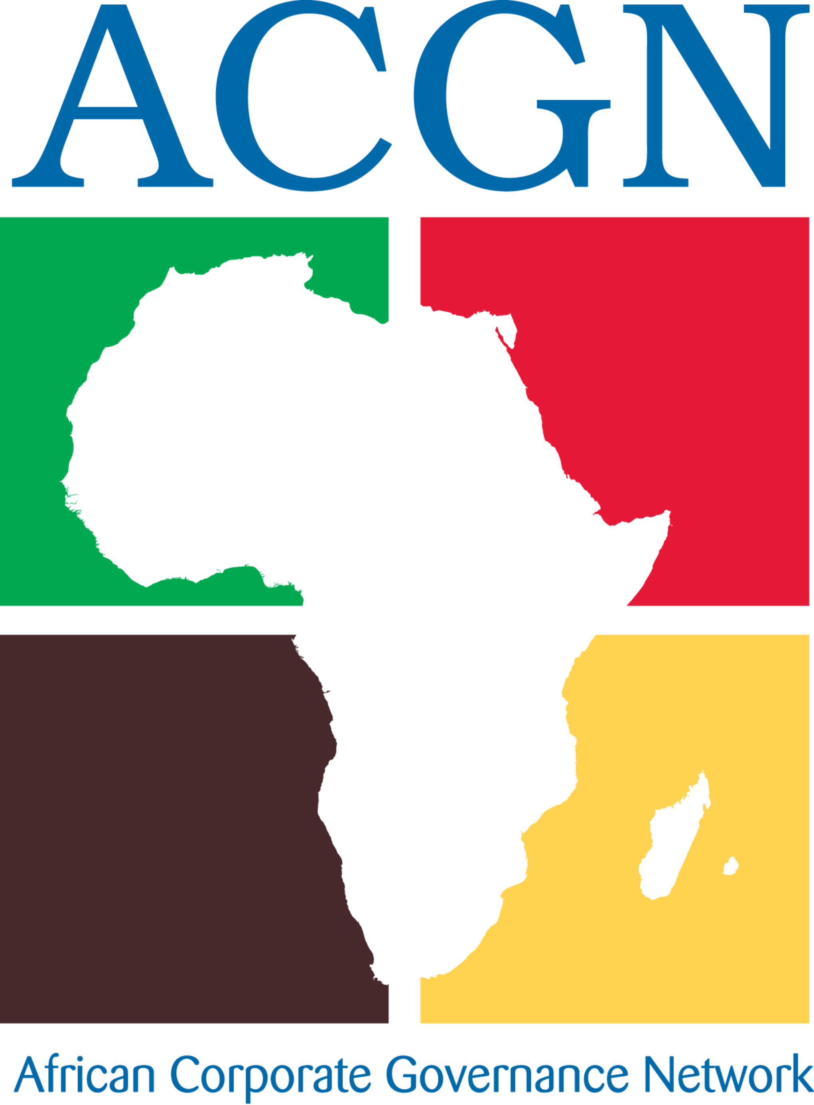**BRIEF PROFILE OF THE AFRICAN CORPORATE GOVERNANCE NETWORK (ACGN)**

*African Corporate Governance Network: Driving Sustainable Growth Through Governance Excellence*

**1. Who We Are**

The African Corporate Governance Network (ACGN) is the continent’s premier membership-based institution dedicated to advancing world-class corporate governance practices. With active IoDs and Governance Institutions in over 20 African countries and a collective reach of more than 20,000 directors, we serve as the unified voice for governance professionals, board members, regulators, and institutions committed to Africa’s sustainable economic future.

**2. Our Mission**

To develop the capacity of the ACGN Members and other stakeholders   
towards enhanced and more effective corporate governance practices aimed at   
building better private and public sector organisations and becoming corporate   
citizens in Africa.

**3. Our Mandate**

ACGN delivers on its mission through three core pillars:  
  
ADVOCACY Influencing policy reforms and governance standards aligned with global best practices (e.g., OECD/UN/ AU Principles) and African realities.  
  
CAPACITY BUILDING   
Certifying directors, facilitating peer learning, and developing future-ready governance leaders.  
  
KNOWLEDGE AND INNOVATION Curating Africa-centric research, tools, and thought leadership on ESG, digital governance, and anti-corruption.

4. Why Governance Matters for Africa’s Future

|  |  |
| --- | --- |
| Challenge | ACGN’s Response |
| Investor confidence gaps | Championing transparency, board accountability and integrated reporting to de-risk investments. |
| Fragmented standards | Harmonizing governance codes across 20+ markets with support from the AU; African Principles and Guidelines for corporate Governance. Standardizing Director competencies across boarders with supoort from the University of Essex. |
| ESG integration lag | Pioneering Africa-specific ESG guidance for climate resilience, gender equity & social impact with support from the IFC. |
| Emerging risks (tech/cyber) | Building director competencies in digital governance and AI ethics. |

**5. Network Advantage: Scale and Impact**

#. 20,000+ Directors Direct access to Africa’s largest community of governance practitioners.  
  
Multi-Sector Reach   
Members span banking, SOEs, NGOs, SMEs, and listed companies.  
  
Pan-African Footprint   
Local expertise coupled with continental cohesion through 20+ member countries.  
  
Trusted Partnerships Formal collaborations with African Union, APRM, IFC, United Nations, University of Kigali Rwanda, Pan-Atlantic University, Ashesi University, University of Essex, Rotary, AfCFTA, Global Compact, and national regulators.

**6. Value Proposition for Stakeholders:**

For Investors and Capital Markets  
Governance excellence = lower risk premiums + sustainable returns.  
#. Access to vetted governance health-checks of African markets/companies.  
#. Co-developing sector-specific governance scorecards (e.g., mining, fintech).  
  
For Governments and Regulators  
ACGN bridges policy intent and boardroom implementation by providing  
#. Technical support for national governance code reforms.  
#. Public-Private dialogue platforms for regulatory sandboxes.  
  
For Corporations  
Future-proof your leadership and stakeholder trust with our  
#. Board evaluation frameworks and director certification.  
#. ESG integration advisory and crisis governance protocols.  
  
Partner with ACGN to:  
#. Invest in Africa’s governance infrastructure for long-term market stability  
#. Collaborate on sectoral governance initiatives (e.g., climate governance, AI ethics)  
#. Leverage our network to upskill boards or assess governance maturity.  
#. Endorse the Pan-African Governance Framework to drive harmonization

**Contact**

Rev. (Mrs.) AngelaCarmenAppiah,FIoD- Gh,  
Chief Executive Officer  
African Corporate Governance Network   
Email: ceo@afcgn.com  
Phone: +233 24 3662528   
Website: www.afcgn.com